**Http Compression**

**On server Side:**

1. Open C:\Windows\System32\inetsrv\config\applicationHost.config file
2. Under <sectionGroup name="system.webServer">, add

<section name="httpCompression" allowDefinition="AppHostOnly" overrideModeDefault="Deny" />

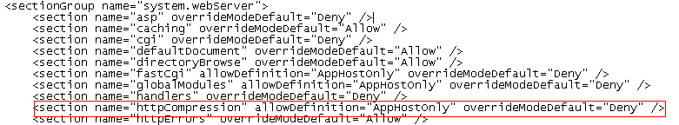

1. Under <system.webServer>, add

<httpCompression directory="%SystemDrive%\inetpub\temp\IIS Temporary Compressed Files">

<scheme name="gzip" dll="%Windir%\system32\inetsrv\gzip.dll" />

<dynamicTypes>

<add mimeType="text/*" enabled="true" />

<add mimeType="message/*" enabled="true" />

<add mimeType="application/x-javascript" enabled="true" />

<add mimeType="*/*" enabled="false" />

<add mimeType="application/xml" enabled="true" />

</dynamicTypes>

<staticTypes>

<add mimeType="text/*" enabled="true" />

<add mimeType="message/*" enabled="true" />

<add mimeType="application/x-javascript" enabled="true" />

<add mimeType="application/atom+xml" enabled="true" />

<add mimeType="application/xaml+xml" enabled="true" />

<add mimeType="*/*" enabled="false" />

</staticTypes>

</httpCompression>

1. In IIS, go to the application, Compression Settings
2. Check the static and dynamic compressions

On Client Side:

1. Start fiddler
2. Make sure the AutoDecode is not pressed

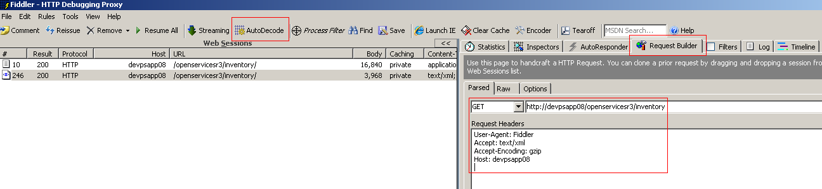

1. Go to the Request builder tab on the right hand side
2. Enter the URL and select the Method
3. In the Request header set the following header fields:

Accept: text/xml

Accept-Encoding: gzip

1. Execute the request
2. Double click on the request generated on the left hand side
3. It shows the request on the left hand top and the response on the left hand bottom
4. Select the raw response to see both the headers and the actual compressed message body

